HCZ Promise Academy Charter Schools

District-wide Emergency Response Plan

Contents
HCZ Promise Academy Charter Schools 1
District-wide Emergency Response Plan 1
Section I: General Considerations and Planning Guidelines 3
Section II: Risk Reduction/Prevention and Intervention 7
Section III: Response 11
Section IV: Recovery 19
Section V: Emergency Telephone Numbers and Web Resources 20

Section I: General Considerations and Planning Guidelines

- Purpose
The HCZ Promise Academy District-wide School Safety Plan was developed pursuant to Commissioner’s Regulation 155.17. At the direction the Superintendent, Dr. Achil Petit, appointed the Promise Academy Central Office and charged it with the development and maintenance of the HCZ Promise District-wide School Safety Plan. The scope of this district-wide safety plan encompasses both Promise Academy I located at 245 West 129th Street, NYC, and Promise Academy II located at 2005 Madison Avenue and 35 East 125th Street, NYC.
- Identification of School Teams
The HCZ Promise Academy Superintendent has charged the Principals of Promise Academy Charters Schools with appointing members of their staff to fill roles within the Building Response Teams. The Promise Academy Building Response Teams consist of, but are not limited to, representatives of the school administrative team and other school personnel and the Harlem Children’s Zone Safety Team.
School Safety Team
In accordance with Section 155.17 (c)(13), HCZ Promise Academy Charters Schools has created a School Safety Team consisting of administrators, HCZ and Promise Academy staff, school safety, and community partners. The School Safety team is the district-wide team for Promise Academy Charter Schools. Although there are members that are specific to a site, every member of the School Safety Team is trained to function as support at any Promise Academy site. The names and contact information for each team member are listed in the table below:
 | Promise Academy I Charter School  245 W. 129th Street |  | Promise Academy II Charter School  35 E. 125th St. & 2005 Madison Ave.
Required Position | Name | Contact Information | Name | Contact Information
Superintendent | Dr. Achil Petit | 212-360-3255 | Dr. Achil Petit | 212-360-3255
School Safety Personnel | Jazmine Lewis | 646-582-1200 | Jazmine Lewis | 646-582-1200
Local Law Enforcement Officials | NYPD 32nd Precinct | 212-690-6311 | NYPD 25th Precinct | 212-860-6511
Administrator | Dr. Joseph Cordero | 212-360-3232 | Kashif Hameed | 212-360-3238
Operations Director | Ajene Christian | 212-360-3233 | Kenneth Ward | 212-360-3237
Parent Coordinator | Jamila Delong | 212-360-3232 | Krystal Velez | 212-360-3237
District Office Coordinator | Kameyia Van Allen | 212-360-3230 | Kameyia Van Allen | 212-360-3230
Social Services | Jessica Lake, Sr Mgr | 212-281-7000 | Jessica Lake, Sr Mgr | 212-281-7000
Additional Support | Promise Academy I Parent Association | 212-360-3230 | Promise Academy II Parent Association | 212-360-3230

Building Response Teams
Building Response Teams (BRTs) are emergency information and action management teams that exist within each school building. The BRT members form the school’s core emergency response groups and are hand selected by the Principal to handle all school or student-related emergency incidents and conditions. On average, BRTs will consist of five members; however, BRT size will be determined on a case-by-case basis. There is a BRT team for each Promise Academy sub-school (i.e. PAI Elementary, PAII Middle, etc). As members of the BRT, these employees are trained to in the General Response Protocol and are also trained in how to collect and provide accurate information on an incident. The roles of the members of the Building Response Team are as follows:
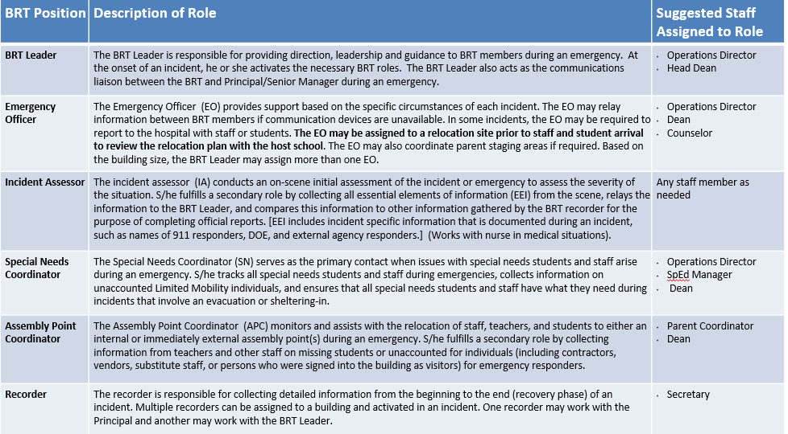

Each BRT team is trained to deal with an emergency involving their respective sub-schools. However, If a district-wide emergency occurs, then all of the BRTs will be activated. The BRT’s for each Promise Academy sub-school are as follows:
Promise Academy I Charter School | Promise Academy II Charter School
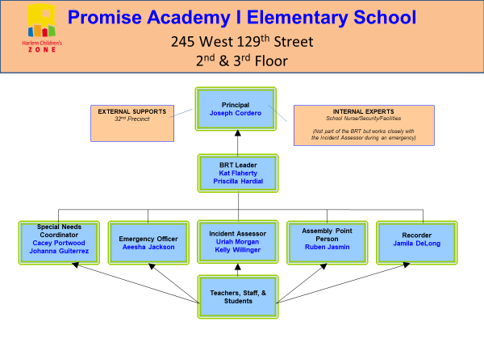 | PAII Elementary (K-5) is co-located in a DOE building at 2005 Madison Avenue. The Building Response Team and Safety Plan for that building is filed with Arthur Schomburg High School (I.S. 201).
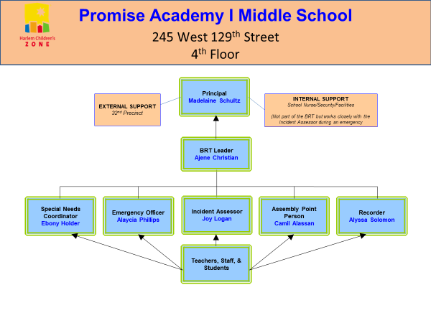 | 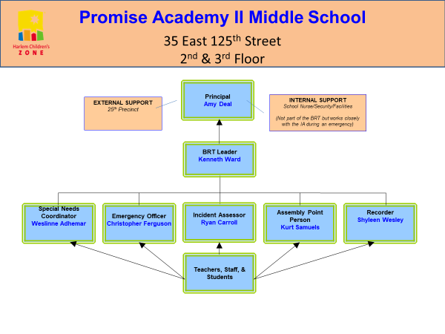
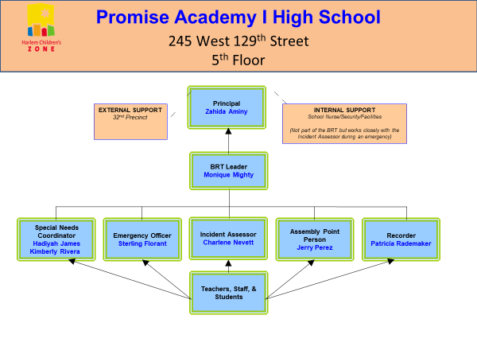 | 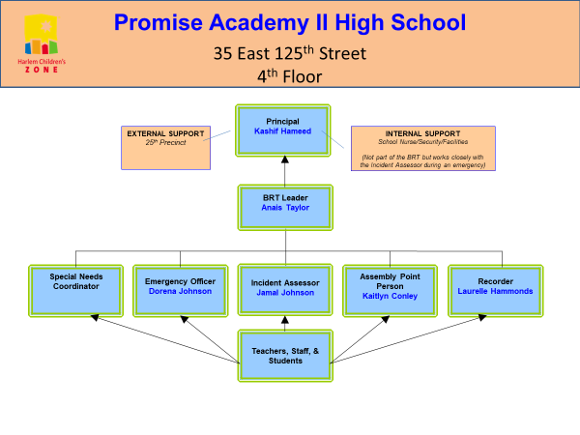

If the emergency occurs when day school has ended and after school is in session, then the after school BRTs will be activated. The After School BRT’s are as follows:
Promise Academy I After School | Promise Academy II After School
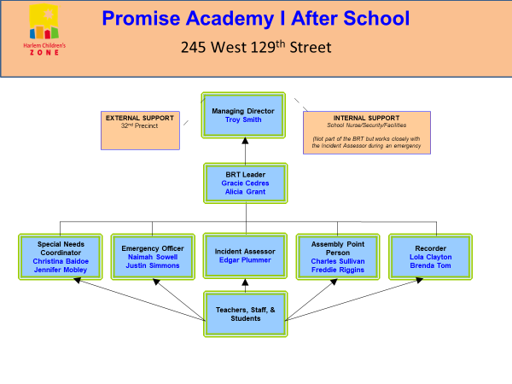 | 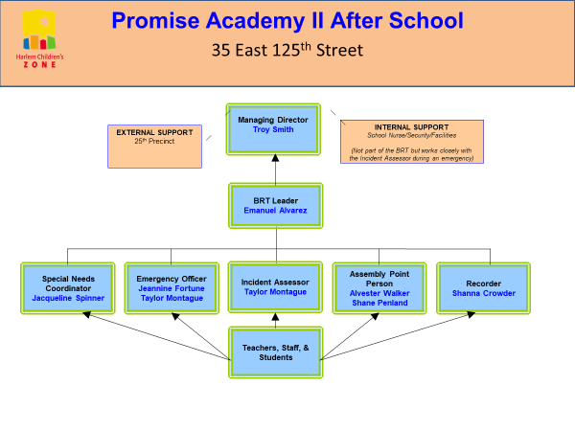

Post-Incident Response Team
The Post-Incident Response team is responsible for the recovery phase – ensuring that the school returns to normal operations as quickly as possible following an emergency or crisis. The members of the Post-Incident Response Team or shown below:
 | Promise Academy I Charter School  245 West 129th Street |  | Promise Academy II Charter School  35 East 125th Street
Required Position | Name | Contact Information | Name | Contact Information
School Personnel | Dr. Joseph Cordero  PAIES Principal  Madelaine Schultz  PAIMS Principal  Zahida Aminy  PAIHS Principal | 646-582-1200 | Amy Deal  PAIIMS Principal  Kashif Hameed  PAIIHS Principal | 646-582-1200
Medical Personnel | Alexandra Covino, NP  Jodi Kunebe, NP  Elizabeth Ring, Director | 646-838-6355 | Alexandra Covino, NP  Jodi Kunebe, NP  Elizabeth Ring, Director | 646-838-6355
School Psychologist | Sabrina Medina, SSW | 212-360-3230 | Sabrina Medina, SSW | 212-360-3230
Crisis Intervention | Victoria Pinderhughes  Licensed Psychologist | 212-961-5752 | Victoria Pinderhughes  Licensed Psychologist | 212-961-5752

- Concept of Operations
The District-wide School Safety Plan is directly linked to the individual Building-level Emergency Response Plans for each school building. (Put how)
The initial response to all emergencies at Promise Academy Charter Schools will be by the BRT for each respective location. If the emergency is localized to a particular sub-school, then the BRT for the appropriate sub-school will be activated. (See Building Response Teams section for details)
Upon activation of one or more Promise Academy BRTs, the Superintendent or his/her designee will be notified and, where appropriate, local emergency officials will also be notified.
After the emergency is over, and there is no longer imminent danger, the post-incident response team will be activated.
During any emergency, the School Safety Team is notified by the Principal of the BRT to obtain support and resources. The School Safety team is trained to cover all schools in Promise Academy. Additionally, in any type of emergency, the Principal of the appropriate sub-school will immediately notify the Superintendent of Promise Academy Charter Schools or his/her designee, and where appropriate, the local emergency officials will also be notified.

- Plan Review
This plan will be reviewed and updated annually by the Superintendent’s Central Office. The annual review will be completed no later than October 15th of each year. The plan will be made available to school personnel once it is approved by the Promise Academy I and II Board of Trustees.
Full copies of the District-wide School Safety Plan and any amendments will be submitted to the New York State Education Department within 30 days of adoption.
This plan will be reviewed periodically during the year and will be maintained by the Superintendent’s Central Office team. A copy of the plan will be available at the Superintendent’s Central Office at 23 West 129th Street. All Principals will also have a copy at each sub-school.

Section II: Risk Reduction/Prevention and Intervention

Discussion: Section II of the plan is used to identify and describe the district’s policies and procedures for reducing the risk of violence; implementing programs and activities for prevention of violence; and establishing clear descriptions of actions that will be taken in the event of a violent incident or other school emergency. Research demonstrates that positive, skills-based approaches can increase the safety of students and teachers in school, as well as improve the community climate. The sample format below provides an example for consideration by districts of one way of organizing the information in the plan.
- Prevention/Intervention Strategies

The areas that Promise Academy Charter Schools Promise Academy Charter Schools believes strongly in the wisdom of implementing violence prevention and intervention protocols as a primary means of ensuring student/school safety. These protocols take the form of Prevention Programs and support services.
Program Initiatives
Promise Academy has a variety of prevention programs to promote a healthy school climate and ensure both students and staff have a safe environment for learning. Classroom teachers at the elementary spend time throughout the year dedicated to character education. Each month is dedicated to a different character trait (Respect, Responsibility, Trustworthiness, Fairness, Caring, etc.). All adults working in the elementary school participate in the program to reward students exhibiting positive behavior, and monthly assemblies are conducted to recognize these students.
The middle and high school has a mentorship program and students with strong behavioral challenges are paired with one adult in the building to serve as their mentor. We enjoy a close relationship with the New York City Police Department and officers assigned to the school conduct anti-bullying workshops for students, parents, and staff during the school year. Approximately 90% of our students participate in our after-school program, which provides academic help and leadership development. Students participate in weekly discussions and activities around subjects such as lifetime decision making, identifying values, communication and critical thinking, social etiquette, conflict resolution and community service. Additionally, Promise Academy students have access to a social worker, guidance counselor, school psychologist and special education manager to ensure that children are succeeding academically and socially. We have recently incorporated restorative justice practices in all grades in Promise Academy to provide scholars with a sense of responsibility for their actions and the skills to engage in conflict resolution. The special education team supports students with Individualized Education Plans, in order to ensure that at-risk children are provided with services and support.
Promise Academy Charter Schools has a Director of Social Emotional Learning. Always looking for ways to prevent scholars from engaging in behaviors that hinder the learning process, the school has begun to incorporate restorative practice as a part of classroom activity in order to train staff and students in conflict resolution.
Promise Academy Charter Schools acknowledges that there are areas close to the school that are challenging. In order to ensure that our scholars have a safe place to go all hours of the day, we provide free breakfast for our scholars at 7:30am, an extended day from 8:00am to 4:00pm, and free after school services from 4:00pm to 6:00pm. Additionally, Promise Academy Charter Schools provides a free summer enrichment program for parents who would like to ensure that their scholars have a place to go during the summer months.

Training, Drills, and Exercises
Annual Multi-Hazard Training for all Staff and Students
Promise Academy Charter Schools has incorporated policies and procedures for annual multi-hazard school safety training for staff. Promise Academy requires all adults working in the school to participate in an annual General Response Protocol training by September 15th as mandated by Education Law §2801-a. This 3-hour training provides participants with an overview of the four phases of emergency management (prevention-mitigation, preparedness, response, and recovery), the roles and responsibilities of the Building Response Team and all adults in the building, and the appropriate response to a variety of threats that our school may face. These threats include: fire, building collapse, active shooter, hostage situation, bomb threats, violence on campus, and natural disasters. Moreover, all adults working at Promise Academy Charter Schools and all attending students are required to participate in all emergency exercises, lock down drills and fire drills. Fire drills will be conducted 12 times during each school year in compliance with the New York State Education Department, eight of which are held prior to December 31. Students also receive bus safety drills three times a year as mandated by Section 3623 of the State Education Law and Revised Title 8, Chapter II, Subchapter J, Section 156.3(f) of the Regulations of the Commissioner of Education. Fire drill schedules are maintained by the District (Central) office.

Implementation of School Security
Security Officers are present 24 hours a day, 7 days a week. The school employs 21 security officers, with five (5) officers on duty at all times when students are on campus. One Security Officer is assigned to each floor of the building that occupies students (4 floors), with an additional officer assigned to the greeter station at the main entrance. The officer assigned to the main entrance is responsible for ensuring the visitor policy for the school is enforced. The security officer utilizes an electronic visitor-badge system while registering visitors in the visitor’s log to ensure that no one with a prior criminal offense against a minor is admitted to the school. The officer at the greeter station is also responsible for monitoring the eighty-three (83) security cameras throughout Promise Academy Charter Schools. The school has fourteen (14) exterior cameras that monitor all entrances to the building and seventy-nine (79) interior cameras placed throughout the school building. In addition to the security monitors at the greeter station, monitors are placed in the security office. The security system records all video for 30 days, with the ability to permanently record and store specific videos. The security camera system is used to both prevent disorder and/or crime, as well as investigate after an incident occurs. A complete list of Standard Operating Procedures is included in the Harlem Children’s Zone Security Officer Manual.

Vital Educational Agency Information
An updated school staff contact list, (that includes cell phone numbers) is maintained by the Superintendent’s District (Central) Office and placed within the Operations Manual. It will include a list of all local emergency contact names and numbers (police, fire, hospital, Board Members, and local officials), emergency contact information for school staff, organizational charts, and a student roster.
  - Early Detection of Potentially Violent Behaviors
Promise Academy Charter Schools has adopted strict policies on expectations for behavior by students, staff members, and visitors regarding violence in our school. These policies can be found in the Promise Academy Family Handbook, HCZ’s Employee Handbook, and in the Code of Conduct signage posted around the building. The Promise Academy Family Handbook has the school’s Behavior and Discipline Code which is aligned with the Department of Education Chancellor’s Regulations. All students and staff members sign School/Family/Scholar Agreement that affirms their commitment to creating a safe learning environment, as well as restating and affirming expected behavior at school. The Family Handbook also communicates to families what interventions are in place to manage behavior.
There are Promise Academy staff members who specialized in detecting challenging behaviors and providing services or information about resources that can help assist families in preventing behaviors that may hinder the learning process. The following staff members are in place to support in this area:
- School Psychologist – Promise Academy Charter Schools has a school psychologist who works with students individually or in groups to help deal with various behavioral issues, learning difficulties, disabilities, emotional problems and other concerns.
- Director of Social/Emotional Learning – Promise Academy Charter Schools has a director of social emotional learning who leads student’s SEL growth including SEL curriculum, embedded SEL instruction, SEL assessment and tiered SEL supports across school. Additionally, the SEL director implements professional learning ensuring that staff are well-trained, equipped and supported to effectively respond to student’s needs.
- Special Education Managers – Promise Academy has three Special Education Managers for both elementary schools, middle and high schools who provide educational assistance, resources and assessments for children who learn differently.
- Behavior Analysts – Promise Academy has two behavior analysts, one for grades K-5 and one for grades 6-12, who support students with development disabilities and study behaviors to treat social, behavioral and learning problems.
- Social Work Team – Promise Academy has social workers in every sub-school who provide services to students to enhance their emotional well-being and improve their academic performance. They also provide support and resources to help students through trauma and problems.
All staff are encouraged to communicate any potentially violent behaviors in students to the school social worker, or in cases of scholars with individualized education plans, to the special education manager. The aforementioned roles are overseen by the Deputy of Special Projects who has an extensive background in special education and social work.
  - Hazard Identification
Harlem Children’s Zone Promise Academy I Charter School is located at 245 West 129th Street, New York, NY. The school was built in 2013 and includes five floors and a basement. The school is visible from neighboring businesses, homes and roadways, and the immediate surroundings are mostly residential apartments. The main entrance to the school is on the corner of Adams Clayton Powell Jr. Blvd. and 129th and each of these streets have heavy traffic. Public transportation is embedded into the neighborhood, with public bus stops on the corner, and subway access to the A, B, C, and D trains on 127th Street. While crime does occur in the neighborhood, crime against the school or school property is rare, but our students have been victims of crimes committed in the vicinity of the school grounds (robbery, gangs).
Harlem Children’s Zone Promise Academy II Charter School is located across two buildings. Grades K-5 are co-located at 2005 Madison Avenue, a DOE building. Grades 6-8 are located at 35 East 125th Street, New York, NY, which was built in 2005 and includes six floors and a basement. The first four floors of the building are occupied by the school and include classrooms, one cafeteria, one gymnasium, and several offices. The 5th and 6th floor encompass office space for employees and executives of Harlem Children’s Zone. The school is visible from neighboring businesses, homes and roadways, and the immediate surroundings are mostly commercial businesses. Businesses in the area include several fast food restaurants that could attract students away from campus. The main entrance to the school is on the corner of Madison and 125th street and each of these streets have heavy traffic. The Metro-North train is two blocks from the school. Public transportation is embedded into the neighborhood, with public bus stops on the corner, and subway access to the 2/3 and 4/5/6 trains a block away on Lexington Avenue. While crime does occur in the neighborhood, crime against the school or school property is extremely rare. In fact, tagging – seen throughout Harlem - is non-existent on school property. 125th Street is over an earthquake fault, which includes our school building.

Section III: Response

  - Notification and Activation (Internal and External Communications)
In the case of a serious violent incident, law enforcement will be called by a member of the School Safety Team. However, all administrative staff members (Principal, Education Directors and Operations Directors) are trained to call 911 if an incident occurs and the Safety Team cannot be contacted or access the area.
A serious violent incident means an incident of violent criminal conduct that is, or appears to be, life threatening and warrants the evacuation of students and/or staff because of an imminent threat to their safety or health, including, but not limited to: riot, hostage-taking, kidnapping, and/or the use of threatened use of a firearm, explosive, bomb, incendiary device, chemical or biological weapon, knife or other dangerous instrument capable of causing death or serious injury (8 NYCRR 155).
In the case of a disaster or act of violence that is a danger to the entire area, the Safety Team and/or the Superintendent’s Central Office will contact all educational agencies in the area.
- Democracy Prep Harlem High School – (212) 932-7791
- Harlem Renaissance High School – (212) 996-3795
- Harlem Village Academies High – (646) 812-9200
- P.S. 79 Horan School – (212) 369-3134
- Success Academy Harlem 1 - (646) 277-7170
- Success Academy Harlem 2 – (646) 442-6600
If an emergency incident occurs that involves a student, a member of the BRT will call the parent’s direct number on file. If an early dismissal is called due to an incident, the administration for each school will send a phone blast to all families.
  - Situational Responses
Promise Academy Charter Schools are aligned with the New York City Department of Education and has adopted a General Response Protocol to manage emergencies and incidents. In any emergency situation, the appropriate BRT for the building or sub-school will be activated and the Safety Team contacted.
Harlem Children’s Zone Promise Academy employs Security Officers and Safety Knights. While the majority of Security Officers’ shifts are during regular school hours, Security Officers are present at the school 7-days a week, 24 hours a day. All Security Officers are employees of Harlem Children’s Zone. Security Officers, as well as all Harlem Children’s Zone employees, undergo a rigorous background, screening, and interview process before employment is offered. The minimum qualifications for a Security Officer include: possession of a current New York State Security Officer’s license; health and physical characteristics suitable for security duties including a physical examination; High School diploma or equivalent; a required criminal history background check; and proof of U.S. citizenship or legal resident alien status. A complete list of Standard Operating Procedures can be found in the Harlem Children’s Zone Security Officer Manual. Twenty-four (24) hours of annual professional development is required of all Security Officers, this training includes training in verbal de-escalation and non-violent physical restraint. New York City Police Officers work closely with school officials and security officers in patrolling the exterior of the school and community, as well as calls for service. The school provides access to the adult restrooms, which has proved to be an excellent practice and strengthened our relationship with police officers and increased their presence around school property.
Responses to Acts of Violence: Implied or Direct Threats
Promise Academy Charter Schools are committed to preventing workplace violence and has adopted the following guidelines to minimize the risk of personal injury to employees, students or visitors. Each employee is expected to refrain from fighting, rowdy behavior, or other conduct that may be dangerous to others or inappropriate for children. It is forbidden for employees to bring firearms, weapons, or other dangerous or hazardous devices or substances onto the premises of Harlem Children’s Zone and Promise Academy Charter Schools.
Threats, threatening language or any other acts of aggression or violence made toward or by any employee will not be tolerated. HCZ Promise Academy will not tolerate conduct that threatens, intimidates, or coerces another employee, an HCZ student, visitor, guest, contractor or candidate for employment. For purposes of this policy, a threat includes any verbal or physical harassment or abuse, any attempt at intimidating or instilling fear in others, menacing gestures, flashing of weapons, stalking or any other hostile, aggressive, injurious and/or destructive action undertaken for the purpose of domination or intimidation.
If there is a threat or incident of violence, employees are instructed to immediately report these incidents to a supervisor, or the Senior Managing Director of Human Resources. This includes threats by employees, students, or visitors. This policy can be found in the Employee Handbook given to each employee upon being hired.
Students of HCZ Promise Academy are expected to abide by the Behavior and Discipline Code in the Family Handbook as well as the Code of Conduct that can be found posted in every Promise Academy building. Each school year, students and families sign an agreement to follow these policies.
If the threat of violence by an employee or a visitor occurs in a school, the BRT is immediately activated and will:
- Make Use of staff trained in de-escalation or other strategies to diffuse the situation.
- Inform Building Principal of implied or direct threat.
- Determine level of threat with Superintendent/Designee.
- Contact appropriate law enforcement agency, if necessary.
- Monitor the situation, adjust response as appropriate, include the possible use of the Emergency Response Team.
Acts of Violence
If an act of violence occurs, the BRT is immediately dispatched. The BRT will:
- Determine the level of threat with Superintendent/Designee.
- If the situation warrants, isolate the immediate area and evacuate if appropriate.
- Inform the Superintendent.
- If necessary, initiate lockdown procedure, and contact appropriate law enforcement agency.
- Monitor the situation; adjust response as appropriate; if necessary, initiate early dismissal, sheltering or evacuation procedures.
Response Protocols
Every staff member is trained in General Response Protocol aligned with the New York City Department of Education. Additional responses include:
- Activating the BRT.
- Using the General Response Protocol to address the emergency appropriately by Evacuating, Sheltering-in, calling a Medical Emergency or a Lock Down
- Procedures to provide transportation, if necessary.
- Procedures to notify parents.
- Procedures to notify media.
- Debriefing procedures.
All schools and facilities within Promise Academy I and II will use the following signals in responding to an emergency.

Soft Lockdown / Hard Lockdown
A lockdown will be called in the following emergency situations:
- an authorized intruder in a Promise Academy building;
- a threat of violence in a Promise Academy building; and/or
- others as determined by the School Safety Team
When you hear this announcement on the public address system, “Attention, this is a soft/hard lockdown”, this means there is a possible threat (soft lockdown) or an imminent threat (hard lockdown) within the building. All members of the BRT should switch radios to the same station for announcement of command post and any instructions during the drill. Anyone in the hallway should quickly duck into the nearest classroom. Teachers and students should:
- turn off lights and lock door;
- move away from the line of sight, make sure they can’t be seen by anyone if someone in the hallway looks through the window of the classroom door; and
- maintain silence.
If someone is in the restroom or another room besides a classroom, that person should:
- turn off the lights and lock door;
- move away from the line of sight; and
- maintain silence.
In a soft lockdown, the Building Response Team should be the only people moving in the hallways. In a hard lockdown, everyone in the building should be:
- turning off lights and locking doors in their respective areas;
- moving away from the line of sight (hiding under desk, etc); and
- maintaining silence.
These protocols should be in effect until the “All Clear” is given.

ME (Medical Emergency)
An ME may be called in the following emergency situations:
- a student, staff member or visitor has been injured or is sick;
- a student, staff member or visitor has displayed severe mental distress; or
- a student, staff member or visitor is displaying behavior that is a danger to themselves or others.
When you hear on the public address system the words, “Attention, ME4”, this means there is a medical emergency on the fourth floor within a Promise building. The floor number should alternate depending on where the medical emergency exists and the BRT for that floor should be activated.
On the floor where the medical emergency exists, teachers and students should continue business as usual within the classrooms but should not leave the classroom until the “All Clear” is given. The ground floor lobby should always be cleared of non-essential personnel by safety officers to allow emergency medical personnel to enter the building easily.
All other staff members should continue their business as usual.

Shelter-in
A Shelter-in may be called in the following emergency situations:
- threats of violence outside of the building;
- dangerous environment outside of the building (i.e. gas leak, hazardous material, bomb threat);
- natural disaster outside of the building (i.e. hurricane and other types of severe weather);
- disturbing incidents outside of the building (i.e. car accident, severe injuries, etc.) and / or
- others as determined by the School Safety Team
When you hear this announcement on the public address system, “Attention, this is a Shelter-In”, this means there is a possible threat or an imminent threat outside of the building. Security personnel will immediately lock all exit doors. When first responders arrive, they will provide direction and assistance to school officials. Teachers, students and staff will be unable to leave the building until the “All Clear” has been given.

Evacuate
An Evacuate may be called in the following emergency situations:
- threats inside of the building (i.e. fire, smoke, gas leak, etc.)
- hazardous material found in the building (i.e asbestos, incendiary device, etc.)
- bomb threat; and / or
- others as determined by the School Safety Team
When you hear this announcement on the public address system, “Attention, please Evacuate!”, this means there is a possible danger inside the building that can be avoided by leaving the facility, such as a fire or smoke.
Teachers will:
- grab the emergency backpack that can be found in each classroom;
- lead students to evacuation location and take attendance; and
- notify staff if there are missing, extra, or injured students using your red and green cards from the emergency backpack.
Students will:
- leave belongings behind;
- form an orderly line;
- remain silent and listen for additional instructions; and
- go to the assigned location with their class.
In the event of fire or smoke, personnel may instruct students and staff members to hold the hands of the person in front and behind them, cover their heads, or crawl on the floor. No staff member or student should re-enter the building until the “all clear” is given.

Emergency Backpacks
Emergency backpacks can be found in every classroom containing essential items that can be used in an emergency. Each backpack includes:
Quantity | Item
12 | Adhesive Bandages
1 | Adhesive Tape
2 | “D” Batteries
2 | Emergency Blankets
11 | Fingertip Bandages
1 | Flashlight
6 | Gauze Pads
1 | Gauze Roll
2 | Ice Packs
1 | Leather Palm Glove
3 | Light Sticks
1 | Marking Crayon
1 | Metal Whistle
30 | Moist Wipes
1 | Notepad
1 | Orange Safety Vest
1 | Pair Latex Gloves
1 | Pen
2 | Signal Cards (1 red, 1 green)
1 | Tissue Pack
6 | Water pouches (4.2 oz)

Signal Cards (during an Evacuation)
At the evacuation site, each classroom teacher/adult with students will hold up either the red or green side of their signal card. The green side indicates that all students are present and accounted for. The red sign indicates missing students or need assistance. The card can be found in the Emergency Backpack in each classroom.

Missing Students All Accounted For
or
Need Assistance

A crisis that takes place at a school impacts the entire community and is likely to draw media attention. Ineffective handling of a crisis can endanger the welfare of all involved and negatively impact the school’s public image with parents, teachers, school boards, and communities. Each Building Response Team must be prepared to contact the Managing Director of Communications or the Director of Communications to respond to the media.
Karen Sodomick, Managing Director of Communications – 212-360-3255
Marty Lipp, Director of Communications – 212-360-3255

Arrangements for Obtaining Emergency Assistance from Local Government
As necessary, the Superintendent or Principal will request assistance from emergency services organizations, first responders, and local government agencies. Contact names and numbers will be maintained in the School Emergency/Safety Plan Binder. A soft and hard copy of this contact information will be maintained by the school principal and stored in the main office. A record will be maintained of all local government emergency assistance requests and responses.

Procedures for Obtaining Advice and Assistance from Local Government Officials
As necessary, the school principal will request advice and assistance from local government officials (borough and city) and agencies such as the Red Cross. Contact names and numbers for all relevant local government officials and agencies, and the Red Cross will be maintained in the school emergency/safety plan binder. A soft and hard copy of this contact information will be maintained by the school principal and stored in the main office. A record will be maintained of all local government officials’ and agencies’ requests and responses including the county or city officials responsible for implementation of Article 2-B of the Executive Law. The types of procedures for obtaining advice and assistance from local governments during countywide emergencies could include the following:
- Principal/Designee in an emergency will contact emergency management coordinator and/or the highest-ranking local government official for obtaining advice and assistance.
- The school has identified resources for an emergency from the following agencies: (examples include the Red Cross, fire department, police department, private industry, private individuals, religious organizations and others).

District Resources Available for Use in an Emergency
Promise Academy Charter Schools have several resources available for use in an emergency. As part of Harlem Children’s Zone, Promise schools can utilize either of the two other school locations for off-site evacuation and shelter. Harlem Children’s Zone employs several adults who are Registered Nurses assigned to work in the schools who can provide first aid in an emergency. Moreover, there are school-based health clinics at 35 East 125th Street and 245 West 129th Street, equipped with doctors and nurses that would be utilized to provide medical care in an emergency. HCZ also employs several mental health professionals that would facilitate counseling and support services after a crisis. HCZ will utilize NYC DOE school buses in an emergency. HCZ includes on-site kitchens that prepare all meals served to HCZ students and has resources (personnel and food and water) to support emergency response and recovery operations at any of the school campuses.

Procedures to Coordinate the Use of School District Resources and Manpower during Emergencies
The School Safety Team will coordinate the use of school district-wide resources and manpower during emergencies, including the identification of the officials authorized to make decisions and the staff members assigned to provide assistance during emergencies. The School Safety Team will respond as follows:
- School cancellation
  - Monitor any situation that may warrant a school cancellation – decision maker/team.
  - Make determination – decision maker.
  - Contact local media.
- Early dismissal
  - Monitor situation – decision maker/team.
  - If conditions warrant, close school – decision maker.
  - Contact Transportation Supervisor to arrange transportation.
  - Contact local media to inform parents of early dismissal Incident Reporting Form
  - Set up an information center so that parents may make inquiries as to the situation.
  - Retain appropriate district personnel until all students have been returned home.

- Evacuation (before, during and after school hours, including security during evacuation and evacuation routes)
  - Determine the level of threat – Superintendent/Designee.
  - Contact Transportation Supervisor to arrange transportation – Designee.
  - Clear all evacuation routes and sites prior to evacuation.
  - Evacuate all staff and students to pre-arranged evacuation sites.
  - Account for all student and staff population. Report any missing staff or students to Building Principal.
  - Make determination regarding early dismissal – Designee.
  - If determination was made to dismiss early, contact local media to inform parents of early dismissal – Incident Reporting Form.
  - Ensure adult supervision or continued school supervision/security.
  - Set up an information center so that parents may make inquires as to the situation.
  - Retain appropriate district personnel until all students have been returned home.
- Sheltering sites (internal and external)
  - Determine the level of threat – Superintendent/Incident Commander/Designee.
  - Determine location of sheltering depending on nature of incident.
  - Account for all students and staff. Report any missing staff or students to designee.
  - Determine other occupants in the building.
  - Make appropriate arrangements for human needs.
  - Take appropriate safety precautions.
  - Establish a public information officer to provide information and current status of the situation to parents and other inquiring parties.
  - Retain appropriate district personnel until all students have been returned home.

Section IV: Recovery

An emergency reaches the recovery phase once the immediate threat is over. During this phase, the Post-Incident Response team will check in with students, staff and senior leaders to ensure that the following takes place:
Mental Health Services
- The managing director of the social work team will dispatch members of her team to check in with staff, students and families who may have suffered emotional or mental trauma, provide them with support and connect with internal and/or external mental health counseling. This counseling may take place long term or short term depending on the need and the level of trauma.
Building Security
- The head of the safety team will direct his/her team to ensure that (1) any gaps in responding to the emergency are addressed and resolved; (2) the area in which the emergency occurred is secured; and (3) reports on the incident are review, addressed and filed appropriately.
- The safety team will also take whatever measures necessary to prevent a similar emergency from happening again by (1) reviewing the cause of the emergency, and (2) putting in whatever preventative measures are required.
Facility Restoration
- Facilities will (1) assess any damage that occurred as the result of the emergency; and (2) ensure that repairs are made as quickly as possible.
- Facilities will also work closely with the safety to make sure that the area is safe for students, staff and visitors.
The Post-Incident Safety team will also ensure that evaluations of violence prevention, safety training, and any other appropriate resources to improve school safety are put in place to mitigate the occurrence and impact of emergency incidents. The contact information for resources that may be used by the Post-Incident Safety Team or by the Building Response Team can be found on the next page.

Section V: Emergency Telephone Numbers and Web Resources

Emergency Telephone Numbers
(This sheet should be laminated and posted in a prominent place in the school office)
Organization / Agency | Contact Number
Emergency | 911
Non-Emergency | 311
Local Police NYPD 25th Precinct (2005 Madison Ave. & 35 E. 125th Street) | 212-860-6511
Local Police NYPD 32nd Precinct (245 West 129th Street) | 212-690-6311
American Red Cross (New York Region) | 877-733-2767
Department of Mental Health (LIFENET) | 800-543-3638
Department of Public Works (Water Emergencies) | 311
Federal Emergency Management Agency (FEMA) | 800-621-3362
National Suicide Prevention Lifeline | 800-273-TALK
New York City Department of Education (Office of School Design and Charter Partnerships) | 212-374-5419
New York City Office of Emergency Management (24 hours) | 311
New York City Environmental Protection | 311
New York State Domestic Violence Hotline | 800-942-6906
New York State Education Department (NYSED) | 718-722-4553
New York State Office of Children and Family Services (Child Abuse Services) | 800-342-3720
New York State Office of Mental Health | 800-597-8481

Local Hospitals
Harlem Hospital, 506 Lenox Avenue, NYC 10037 212.939.1000
St. Luke’s Hospital, 1111 Amsterdam Avenue, NYC 10025 212.523.4000

Radio Stations
Emergency Broadcasts can be received via the Emergency Alert System (ES).
WINS 1010 AM
WCBS 880 AM
WABC 770 AM

Web Resources

American Academy of Pediatrics, Disaster Preparedness to meet Children’s Needs - https://www.aap.org/en-us/advocacy-and-policy/aap-health-initiatives/Children-and-Disasters/Pages/default.aspx
American Red Cross, Masters of Disaster – http://www.redcross.org/
Federal Emergency Management Agency (FEMA), Recovery Support Functions – https://www.fema.gov/recovery-support-functions
Federal Emergency Management Agency (FEMA), Emergency Management Institute - https://training.fema.gov/
Federal Emergency Management Agency (FEMA), Ready.gov - www.ready.gov
National Association of School Psychologists, Crisis and Safety Resources – http://www.nasponline.org
National Organization on Disability (Preparedness for Children with Disabilities) – http://www.nod.org
National School Safety Center - www.schoolsafety.us
NYC Department of Education, Emergency Readiness – https://www.schools.nyc.gov/school-life/support/emergency-readiness
NYC Department of Education, Safety Preparedness Video - https://vimeo.com/116014892
NYC Housing Preservation & Development - https://www1.nyc.gov/site/hpd/renters/emergency-preparedness.page
NYC Office of Emergency Management, Plan for Hazards- https://www1.nyc.gov/site/em/ready/plan-hazards.page
NYC Office of Emergency Management, Community Emergency Response Teams (CERT) - http://home2.nyc.gov/html/oem/html/get_prepared/cert.shtml
NYC Office of Emergency Management, Ready New York - http://www.nyc.gov/html/oem/html/get_prepared/ready.shtml
NYC Police Department, Safety Tips for Children https://www1.nyc.gov/assets/nypd/downloads/pdf/crime_prevention/NYPDcptips_BackToSchool.pdf
NYS Center for School Safety – http://www.nyscenterforschoolsafety.org
NYS Emergency Management Office, (SEMO) Transportation Events, Road Closures, etc. - http://www.nyalert.gov/
NYS Office of Mental Health, Violence Prevention -http://www.omh.state.ny.us/omhweb/sv/SchlViol.htm

